Research paper

Imarsys 06

Mini project:

creating and parameterizing a small ecosystem NPZD-V model in R

course instructor(s):

Dr. Elisa Schaum

Luisa Listmann

Jana Hinners

Author:

Amirhossein Feiz

[emier.fman1997@gmail.com](mailto:emier.fman1997@gmail.com)

**S5 SuSe2021**

**1.Introduction**

We want to understand the fate of biomass produced by phytoplankton through carbon cycle when we add viral infection, zooplankton grazers or investigate how do they affect plankton population.

Phytoplankton are primary producers and they actually play an essential role in carbon cycle. so they are important because they are starting point of marine biogeochemical cycles, protistan (unicellular eukaryotic) phytoplankton have long been recognized as foundation al to fisheries and export of atmospheric CO2 to the deep ocean, (M. B. Higgins, et al 2012)( [PG Falkowski](https://scholar.google.com/citations?user=4lHobcAAAAAJ&hl=en&oi=sra) - Photosynthesis research, 1994 – Springer). Phytoplankton convert CO2 to organic carbon via photosynthesis, simultaneously altering cycles of other elements linked to carbon by the stoichiometry of cellular composition. Thus, the carbon cycle interacts with biogeochemical cycles of nitrogen, silica, and many other elements (J. P. Zehr, R. M. Kudela, Nitrogen cycle of the open ocean: From genes to ecosystems.2011). (Joseph H. Street and Adina Paytan Marine Chemistry, 2008 - Elsevier). Phytoplankton populations are controlled both by bottom up (nutrient, light, temperature) and top-down mechanisms (viral infection, zooplankton grazing) which can influence the “distribution” of biomass within an ecosystem. (H.W.Harvey et al 11 may 2009) (M. R. Landry 1984).viruses (that affect phytoplankton) are also an important factor that influences the balance of phytoplankton productivity, export production how they keep food web running and keep the food available for higher trophic levels. Also, addition to sea water of particles in the 0.002–0.2 μm size range, concentrated from sea water by ultrafiltration, reduced primary productivity ([14C] bicarbonate incorporation) by as much as 78%. These results (CA Suttle et al - Nature, 1990) (Borsheim, K. Y., *envir. Microbiool.* 1990)(Proctor, L. M. et al -*Nature* 1989) (Ian Hewson et al 2001) indicate that, in addition to grazing and nutrient limitation, infection by viruses could be a factor regulating phytoplankton community structure and primary productivity in the oceans. the quantity of virilizes is not what we know and measuring it in the way going out wild is a difficult work to be done then we look at it mathematically to investigate how rates effect this carbon cycle thus we need to create a small ecosystem model, parametrize it and run it inside the R software to follow the changes the food web with the new virilizes and grazing rates. For this purpose ( providing a mathematical look) a variety of biological models have been developed (e.g., EvansandParslow,1985; Fasham et al,1990; SteeleandHenderson,1992; HurttandArmstrong,1999; Doney et al., 1996; Moore et al., 2001). These models differ in complexity, from simple models containing three biological state variables up to more complex ones with, presently, some thirty compartments. The nitrogen-based ecosystem model developed by Fasham et al. (1990) (hereafter named FDM-model) has become a standard model used in various studies ranging from zero-dimensional mixed-layer applications to fully three-dimensional coupled ecosystem circulation models. Nitrogen-based ecosystem model, composed of four state variables (NPZD model). (M Schartau, et al- Journal of Marine Research, 2003). Basic NPZD models can show the flow of biomass through the food web levels within an ecosystem. Within the mini project, we want to add a viral component to a NPZD model and thus build a NPZD-virus model. Such a model will be the basis for i) parametrization experiments of viral lysis and grazing experiments and ii) integration into water body models of the Baltic Sea. (Garrett and Loder 1981) (Rucheng Tian et al 2015 ICES journal)

Conclusion need

**2.Material and methods**

**2.1. Model Deﬁnition**

In all ecosystems there are interactions and biomass flow through the compartements each flow needs to be characterized by parameters and indicates dependence of one compartement on the other.

**2.1.1 NPZD-V diagram**

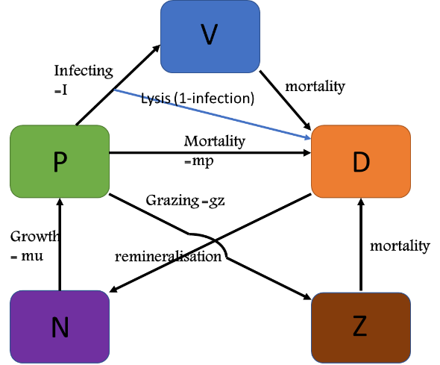Basic NPZD models can show the flow of biomass through the basic food web levels within an ecosystem, an element of V (virus) was added to this model. In order to understand better, a diagram drew to indicate biomass flow through the compartements. This is 4-compartment nutrients-phytoplankton-zooplankton-detritus (NPZD) model plus V.

**Figure1**: The NPZD-V model consists of five state variables: Nitrogen (N; dissolved inorganic nitrogen), Phytoplankton (P), Zooplankton (Z), and Detritus (D) and Virus(V) and seven processes controlling trophic links and remineralization

**2.1.2 equations and parameters**

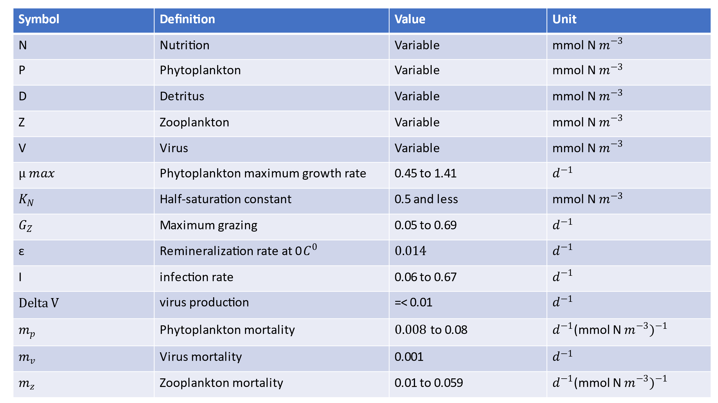The arrows in figre 1 indicate biomass flow through the compartements and for each arrows an equation is writen. Simply N🡪P means: P is dependant on N which will be indicated in the equation as P*“N“ but then needs sevaral parameters that describe the dependance.

**Equations**

dN <- - mu*P*(N/(N+kN)) + ε *N*D

dP <- mu*P*(N/(N+kN)) - I*P*V - gz*P*Z - mp*P

dV <- deltaV*I*P*V – $m_{v}$*V*D

dZ <- gz*P*Z – Z $m_{z}$* *D

dD <- $m_{p}$*P+ P*I*D + P $m_{p}$* *D + V $m_{v}$* *D - ε*N*D

**Table 1**. Parameter deﬁnition, values, and units of the NPZD model(**Ji et al., 2008**)(parameters in reference).

**2.3 BUILDING NPZD-V model IN R**

The experiment was conducted with the following materials: equations mentioned Parameter deﬁnition, units, and values. The initial condition of parameters was speciﬁed using the December climatological data obtained through an objective analysis (The OA was done using the software developed by Bedford Institute of Oceanography (Hendry and He, 1996)). Data sources include the National Oceanographic Data Center(www.nodc.noaa.gov), the Canadian Marine Environmental Data Service (MESD, provided by Dr Pierre Clement) and the University of Maine Database (provided by Dr Dave Townsend). Numerical method was Isoda. Because of different values of the parameters found in different papers , the mean used to make the model.

**3.Results**

**3.1. Model Validation**

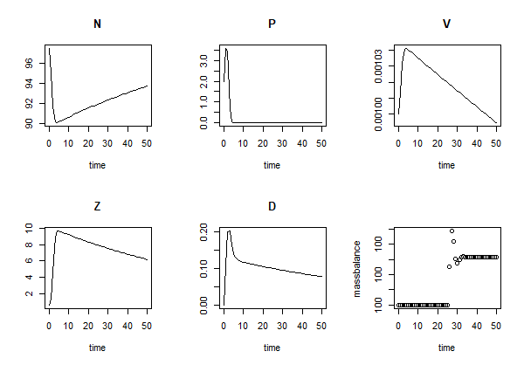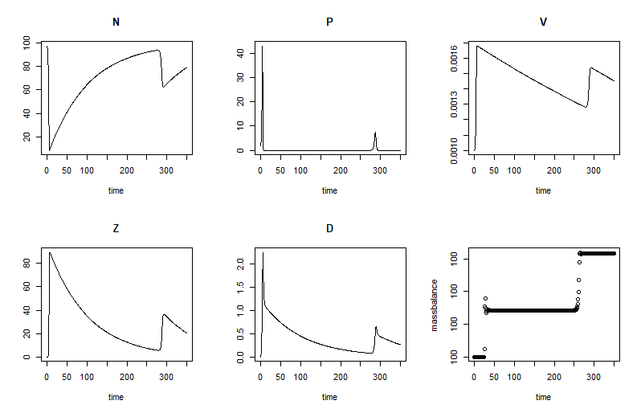The reference simulation features a pronounced bloom in zooplankton, Virus and a sharp increase in phytoplankton and detritus parallel to a complete drawdown in nutrition in the first 10 days, followed by a slow decrease in all parameters mentioned while phytoplankton decreased to near 0 and the first bloom at deplete nutrient conditions (Figure 2A). Using measured zooplankton as external forcing leads to a nearly precise reconstruction of the second phytoplankton bloom, including the differences between 50 days to 1000 days, which approves a high skill in particular of the NPZD-V model from time to time (Figure 2B). The variations in individual process rates shown in (Figure 2B) disclose possible mechanisms underlying the observed phytoplankton dynamics and how their relevance is changing through the different growth phases. During the initial phase of the simulation, phytoplankton biomass decreased sharply due to aggregation until day ∼ 10 and remained near 0. Later around day 280, with gradual drawdown of nutrients (Figure 2B), phytoplankton peaks while virus, zooplankton and Detritus were decreasing until this day they also experienced an increase and instantly returned to their decreasing situation. This trend (day10 to day300) repeated over and over at different initial condition. A glance at Zooplankton and Nutrients diagrams, demonstrated an inverse relationship how from beginning to the end when one increased the other decreased.

**Figure2**: Comparison between phytoplankton, Zooplankton, Virus, Nutrient and detritus of the reference run in first 50 days (left) and 350 days (right).

**3.2. Stressor Effects**

**3.2.1 Grazer Removal**:

Removal of much of the zooplankton standing stock (Figure 3A) results in a transient increase, followed by a transient decrease, of phytoplankton and Detritus (Figure 3A). However, the trend in nutrient is reversed compared to the reference run, as during the time of relieved grazing pressure, phytoplankton remains much limited by nutrients. The removal of grazers slightly favors intermediate virus, so that this sharply recover from very low biomass levels (Figure 3A), while after day 10 virus biomass started to decrease and phytoplankton remain unaffected.

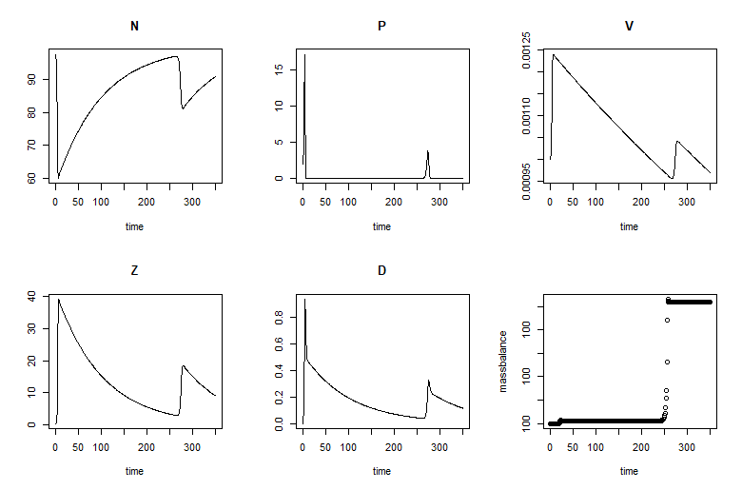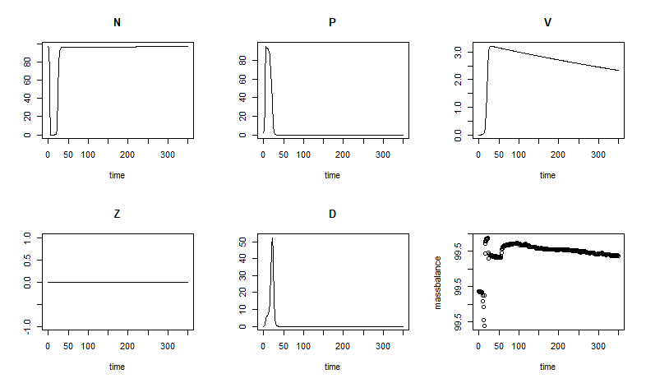Directly after injection of grazers, resulting in lower phytoplankton biomass production (Figures 3B). After a short delay, also simulated nutrient started to grow. The higher biomass level of zooplankton grazers translated to increase top-down control of phytoplankton. In comparison with the reference run virus biomass decreased faster in period of day10 to day 280.

**Figure3**: Comparison between the model with zooplankton grazers (left) and without (right) them in 350 days.

**3.2.2 Virus Removal:**

Removal of virus simply results in the cycles of increase and decrease over 300 days of the experiment (Figure 4 left), comparing to the reference run, nutrition amount decreased at first place same as before and instantly raised near 10th day did not drop after 280 days and continued increasing to hover in the higher numbers, the same situation went for the zooplankton biomass and detritus inversely, after a large fluctuation over the first 10 days continued decreasing to near 0. Phytoplankton biomass stayed at 0 for the rest of the time after fluctuation in the first 5 days.

Directly after increasing of the viral infection rate at day 280, total virus biomass of the model community increases, resulting in no higher phytoplankton biomass production (Figures 4 right). After a short delay, also simulated zooplankton starts decrease same as the reference run. The higher biomass level of viruses translated to no control of zooplankton or phytoplankton.

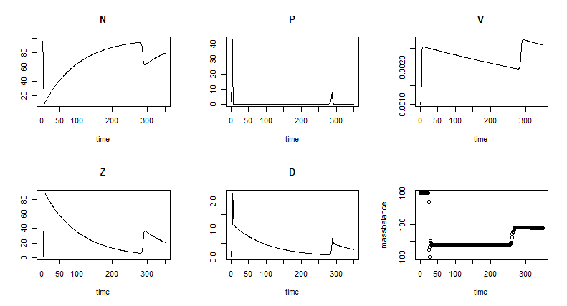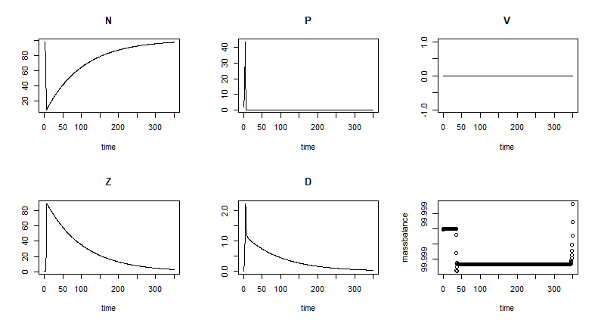

**Figure4**: Comparison between the model with virus (left) and without them (right) in 350 days.

**3.2.3 Virus Removal and Grazer Removal as a multiple stressor**:

Both virus and zooplankton removal, when acting as single stressors, increase the phytoplankton standing stock directly after exposure as explained above. Also, when both are applied at the same time, net growth rates increase (Figure 5 left). The first 20 days after exposure, changes in the phytoplankton community dynamics are similar to the ones in the reference run scenario (Figures 5 right). Here phytoplankton and detritus reached to the top level of possible.

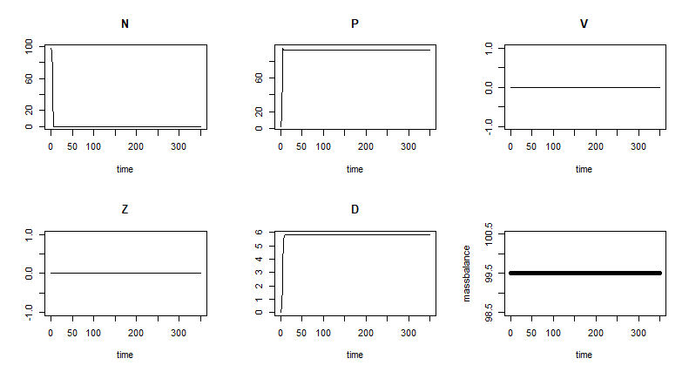

**Figure5**: Comparison between the model aggregation with virus and (right) and without them (left) in 350 days.

**Reference**

(M. B. Higgins, et al 2012) ( [PG Falkowski](https://scholar.google.com/citations?user=4lHobcAAAAAJ&hl=en&oi=sra) - Photosynthesis research, 1994 – Springer)

(J. P. Zehr, R. M. Kudela, Nitrogen cycle of the open ocean: From genes to ecosystems.2011). (Joseph H. Street and Adina Paytan Marine Chemistry, 2008 - Elsevier)

(H.W.Harvey et al 11 may 2009) (M. R. Landry 1984)

(CA Suttle et al - Nature, 1990) (Borsheim, K. Y., *envir. Microbiool.* 1990)(Proctor, L. M. et al -*Nature* 1989) (Ian Hewson et al 2001)

(e.g., EvansandParslow,1985; Fasham et al,1990; SteeleandHenderson,1992; HurttandArmstrong,1999; Doney et al., 1996; Moore et al., 2001)

(M Schartau, et al- Journal of Marine Research, 2003)

(Garrett and Loder 1981) (Rucheng Tian et al 2015 ICES journal)

(Hendry and He, 1996). Data sources include the National Oceanographic Data Center (www.nodc.noaa.gov), the Canadian Marine Environmental Data Service (MESD, provided by Dr Pierre Clement) and the University of Maine Database (provided by Dr Dave Townsend)

[Laura Arin](javascript:;), [Xosé Anxelu G. Morán](javascript:;), [Marta Estrada](javascript:;)

Journal of Plankton Research, Volume 24, Issue 10, October 2002

Predicting marine phytoplankton maximum growth rates from temperature: Improving on the Eppley curve using quantile regression Jan E. Bissinger1 and David J. S. Montagnes

mumax = 0.81e0.0631T

Fishery Bulletin: mumax= 0.851(1.066)T

Zooplankton grazing and growth: Scaling within the 2-2,000-~III body size range

Per Juel Hansen and Peter Koefoed Bj@msen’

Marine Biological Laboratory, Strandpromenaden 5, DK-3000 Hclsingor, Denmark

Dynamics of a lytic virus infecting the photosynthetic marine picoflagellate Micromonas pusilla Matthew T. CottrelP and Curtis A. Suttle

HALF-SATURATION CONSTANTS FOR UPTAKE OF NITRATE AND AMMONIUM BY MARINE PHYTOPLANKTON1 Richard W. Eppley, Jane N. Rogers, and James J. McCarthy Institute of Marine Resources, University of California, San Diego, La Jolla 92037

Mechanisms and Rates of Decay of Marine Viruses in Seawater †

Curtis A. Suttle* and Feng Chen

Marine Science Institute, The University of Texas at Austin, P.O. Box 1267, Port Aransas, Texas 78373-

Wilhelm & Suttle 1999, Weinbauer 2004

Wilhelm et al. 1998

Quantification of Viral and Prokaryotic Production Rates in Benthic Ecosystems: A Methods Comparison

Eugenio Rastelli,1,2 Antonio Dell’Anno,1 Cinzia Corinaldesi,1 Mathias Middelboe,3 Rachel T. Noble,4 and Roberto Danovaro1,2,*